**Technical Challenge**

We understand your time is precious, but as discussed, we ask each applicant to take on our small challenges. There is no right or wrong approach and we're certainly not expecting war and peace 😊. We would expect no more than 30 minutes per challenge, if at the end of the time you haven’t completed don’t worry just send us what you have. (Uploaded to a public GIT repository – ensuring there is nothing KPMG sensitive in the test below there is no need for anything to be)

**Challenge #1**

A 3-tier environment is a common setup. Use a tool of your choosing/familiarity create these resources. Please remember we will not be judged on the outcome but more focusing on the approach, style and reproducibility.

Ans:- Below is the 3 tier environment standard diagram:-

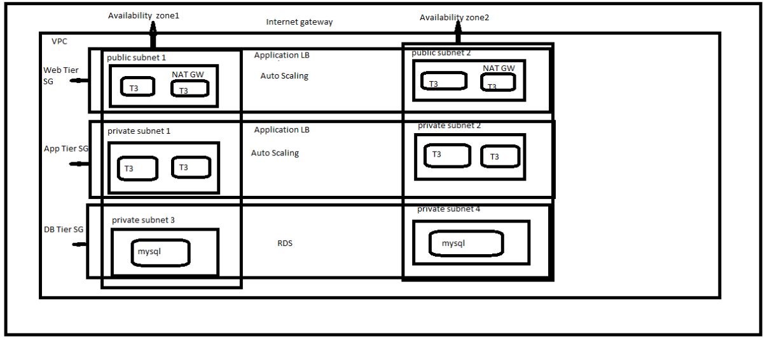

**Challenge #2**

We need to write code that will query the meta data of an instance within AWS and provide a json formatted output. The choice of language and implementation is up to you.

**Bonus Points**

The code allows for a particular data key to be retrieved individually

Hints

·         Aws Documentation (<https://docs.aws.amazon.com/>)

·         Azure Documentation (<https://docs.microsoft.com/en-us/azure/?product=featured>)

·         Google Documentation (<https://cloud.google.com/docs>)

We have following two options which can utilize to query meta data.

Ans:- 1) curl http://"ip address of instance"/latest/meta-data/instance-id

2)

#!/bin/bash

export AWS_ACCESS_KEY_ID="XYZ"(for example)

export AWS_SECRET_ACCESS_KEY="ABC"(for example)

export AWS_DEFAULT_REGION="us-east-1"(for example)

export AWS_DEFAULT_OUTPUT_FORMAT="json"

var='aws ec2 describe-instance-attribute --instance-id i-xyz(for example) --attribute instanceType --region us-easr-1(for example)'

echo "$var"

**Challenge #3**

We have a nested object, we would like a function that you pass in the object and a key and get back the value. How this is implemented is up to you.

Example Inputs

object = {“a”:{“b”:{“c”:”d”}}}

key = a/b/c

object = {“x”:{“y”:{“z”:”a”}}}

key = x/y/z

value = a

Ans:- let obj = {

a: {

b: {

nested: true

},

},

c: {

d: 'zl',

}

};

function getObjectKeys(object, key) {

const keys = key.split('.');

let obj = object;

for (let ikey of keys) {

for (let [objKey, value] of Object.entries(obj)) {

if(!keys.includes(objKey)) {

continue;

}

obj = value;

}

}

return obj;

}

Console.log(getObjectKeys (obj, ‘a.b.nested’));

Console.log(getObjectKeys (obj, ‘c,d’));

Console.log(getObjectKeys (obj, ‘c.d.nested’));

Output Result :- 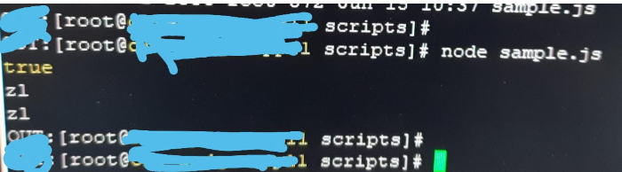

Hints:

*We would like to see some tests. A quick read to help you along the way*

*We would expect it in any other language apart from elixir.*

[*A quick read to help you along the way*](https://hexdocs.pm/elixir/master/Kernel.html#get_in/2)

Once this has been completed please send us the output so we can get the ball rolling.